We are seeking students in Grade 4-6 to take on the role of Morning Announcer.

Morning Announcers Needed

The requirements for this position are listed below. The Learning Skills and Work Habits you will have the opportunity to build and demonstrate are shown in brackets after the tasks followed by other words in italics that can be used to describe the same work habit.

For example, a coach or volunteer supervisor may have said you are “Reliable” and have good “Teamwork” skills. This is like saying you are “Responsible” and a good “Collaborator”. Knowing different words used to describe work habits can help you relate your school experiences to your experiences outside the classroom.

As a Morning Announcer, you will also have an opportunity to build and demonstrate your Essential Skills. These
skills are used in work, learning and life. Essential Skills are shown in bold after the work habits.

• Arrive at the office 15 minutes before school starts. (Responsibility, Reliability, Scheduling or Budgeting and
Accounting)

• Double check the schedule to ensure that it is your day and to double check who your partner is. (Responsibility,
Reliability, Document Use)

• Practice all announcements so you will be able to read them fluently and with expression. (Working
Independently, Reading Text, Oral Communication).

• Work collaboratively with your assigned partner to decide the role of each person for the announcements and the
“flow of the announcements”. (Organization, Collaboration, Teamwork, Decision Making, Oral Communication)

• Select the version of “O Canada” and ensure that it is in the CD player ready to be played. (Organization,
Decision Making)

• Double check the hallways and together with an administrator determine the correct time to start the announcements. (Responsibility, Collaboration, Teamwork)
• Follow the template for the morning announcement routine and make all daily announcements. (Responsibility,
Reliability, Reading Text, Oral Communication, Document Use)

• Be a Reading role model for all students. (Self-Regulation, Responsibility, Reliability, Customer Service, Reading
Text)

• Find a replacement Announcer should you be unable to complete one of your shifts. (Responsibility, Initiative,
Reliability)

• Decide when to ask for assistance with technical problems, etc. (Self-advocacy, Decision Making)

You can transfer your Essential Skills and work habits to everyday life or the next place you go – whether it’s
Morning Announcer - page 2
further education, training or the workplace. More information on how you use your Essential Skills and work habits in everyday life is on the Ontario Skills Passport website.
Identifying and reflecting on the Essential Skills and work habits you demonstrate as a Morning Announcer will
help you develop your “All About Me” portfolio as you answer the four education and career/life planning inquiry questions: Who am I? What are my opportunities? Who do I want to become? What is my plan for achieving my goals?

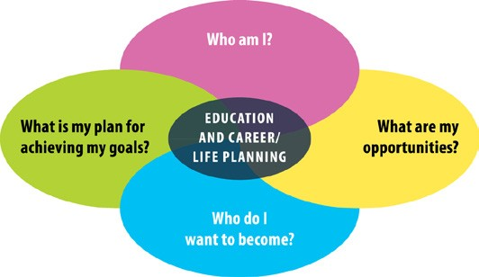

ontario.ca/skillspassport

